**PROJECT 2 (AWS)**

**Host Static Website Using Only S3 (No EC2)**

You already integrated S3. Now:

**Goal:**

* Enable Static Website Hosting in S3
* Configure bucket policy
* Make it public
* Access via S3 endpoint

**Concepts you’ll learn:**

* S3 permissions
* Bucket policies
* Public access block
* Hosting without server

**No server needed because:**

* Static websites don’t need backend processing
* S3 can directly serve files to users

Create an S3 Bucket

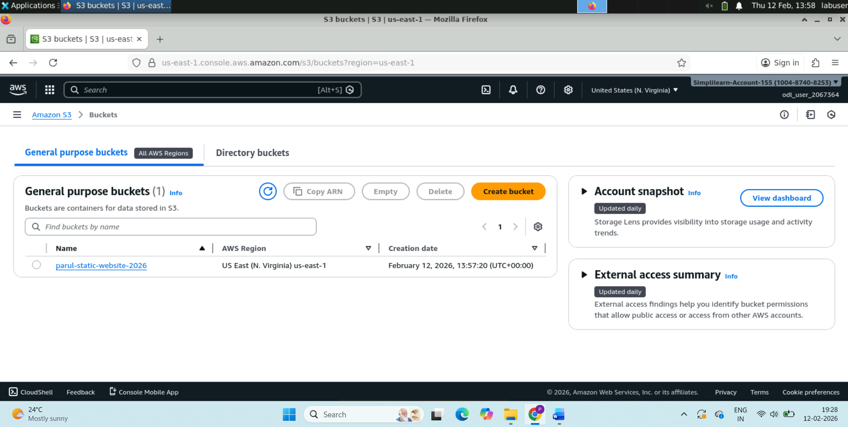

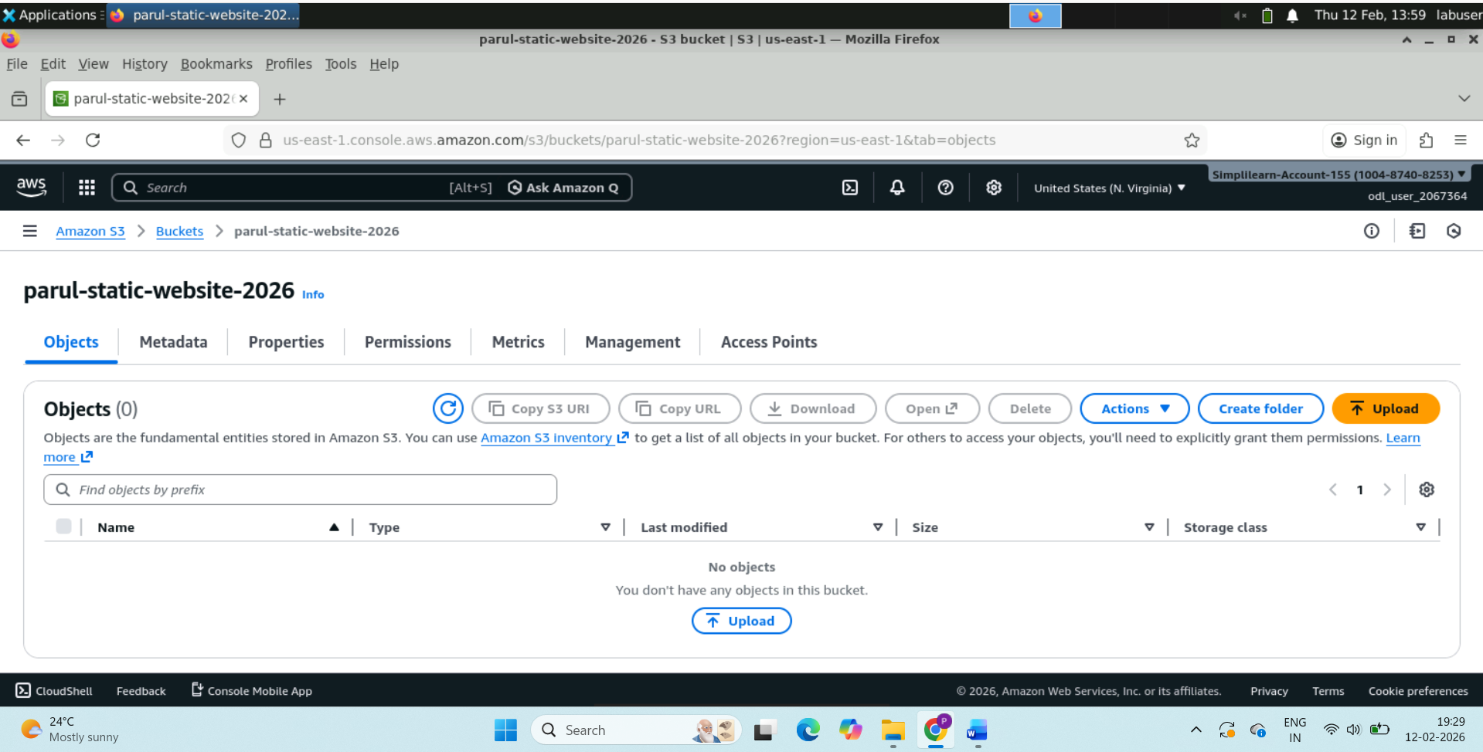

Upload Website Files

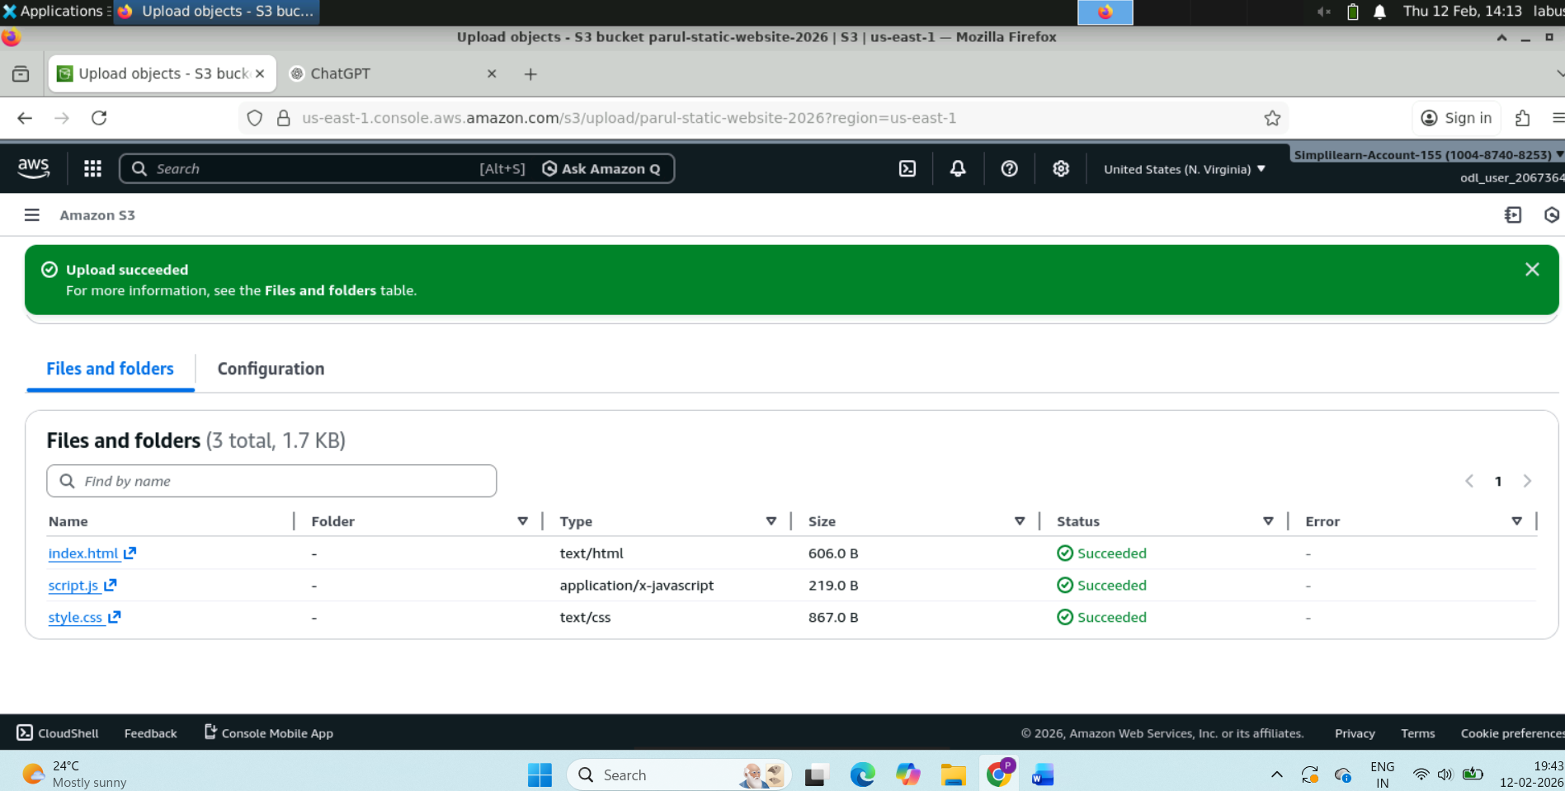

Making files public meaning “Anyone on internet can read files inside this bucket.”

{

"Version": "2012-10-17",

"Statement": [

{

"Sid": "PublicReadGetObject",

"Effect": "Allow",

"Principal": "*",

"Action": "s3:GetObject",

"Resource": "arn:aws:s3:::parul-static-website-2026/*"

}

]

}

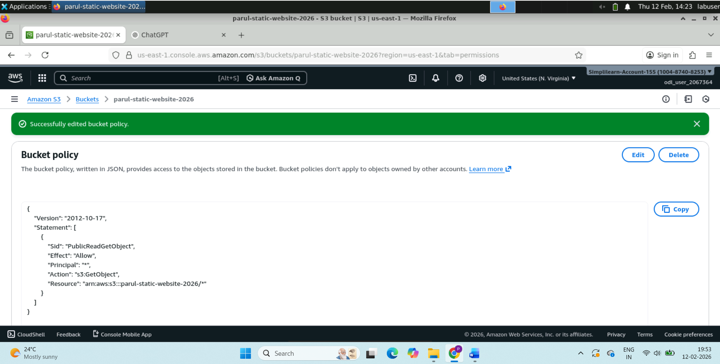

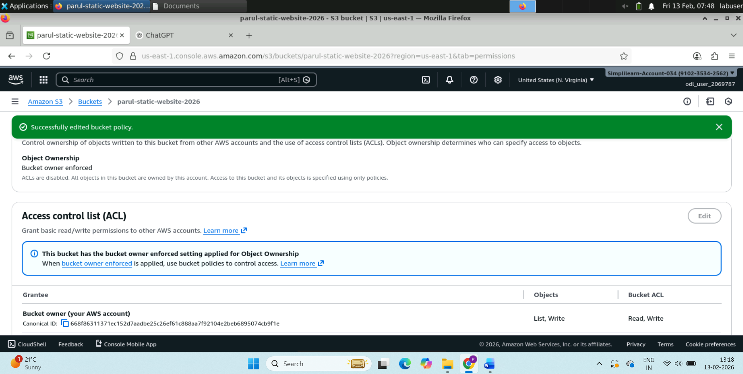

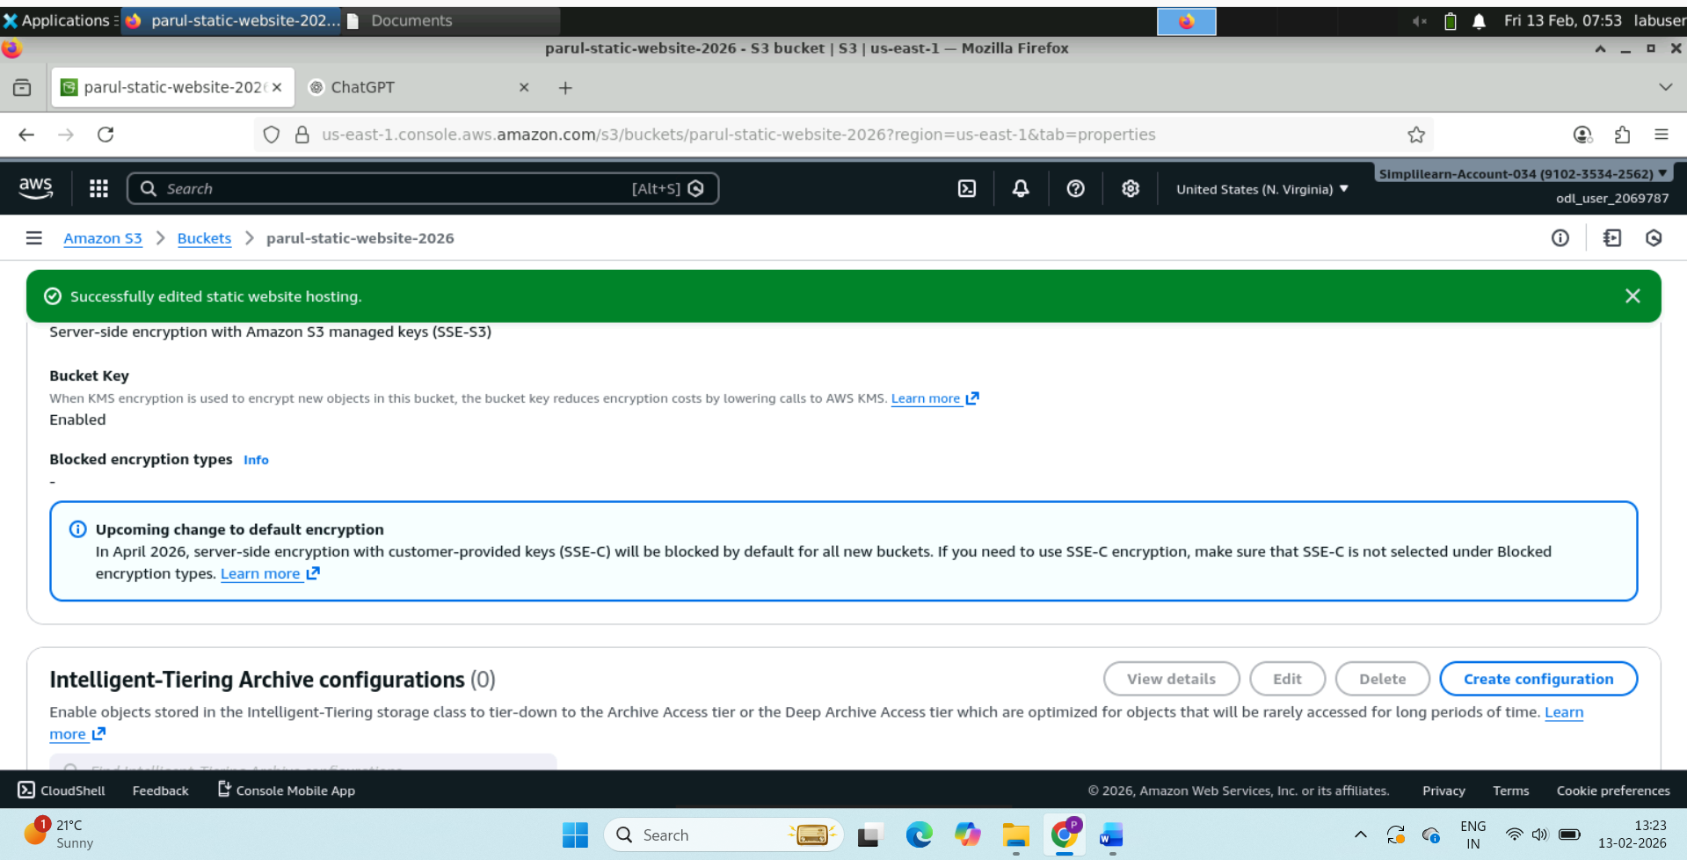

Enable Static Website Hosting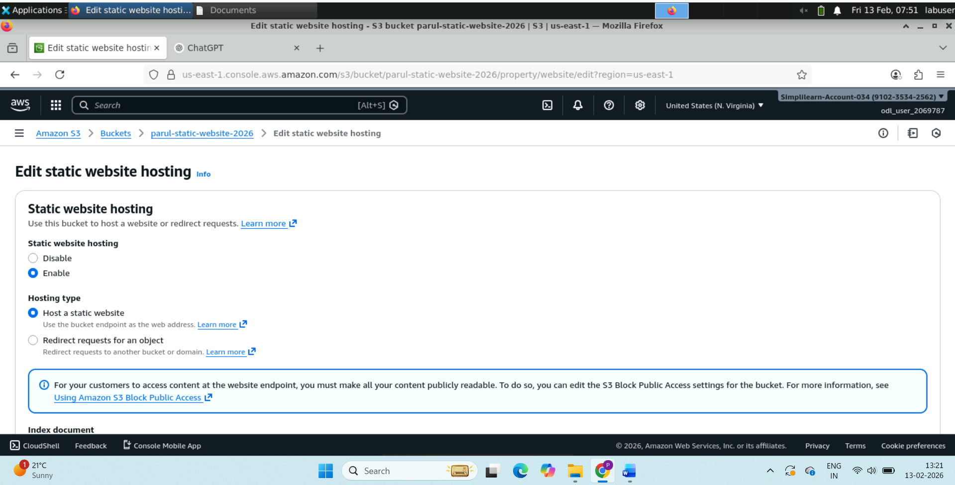

👉 **Bucket website endpoint URL**  
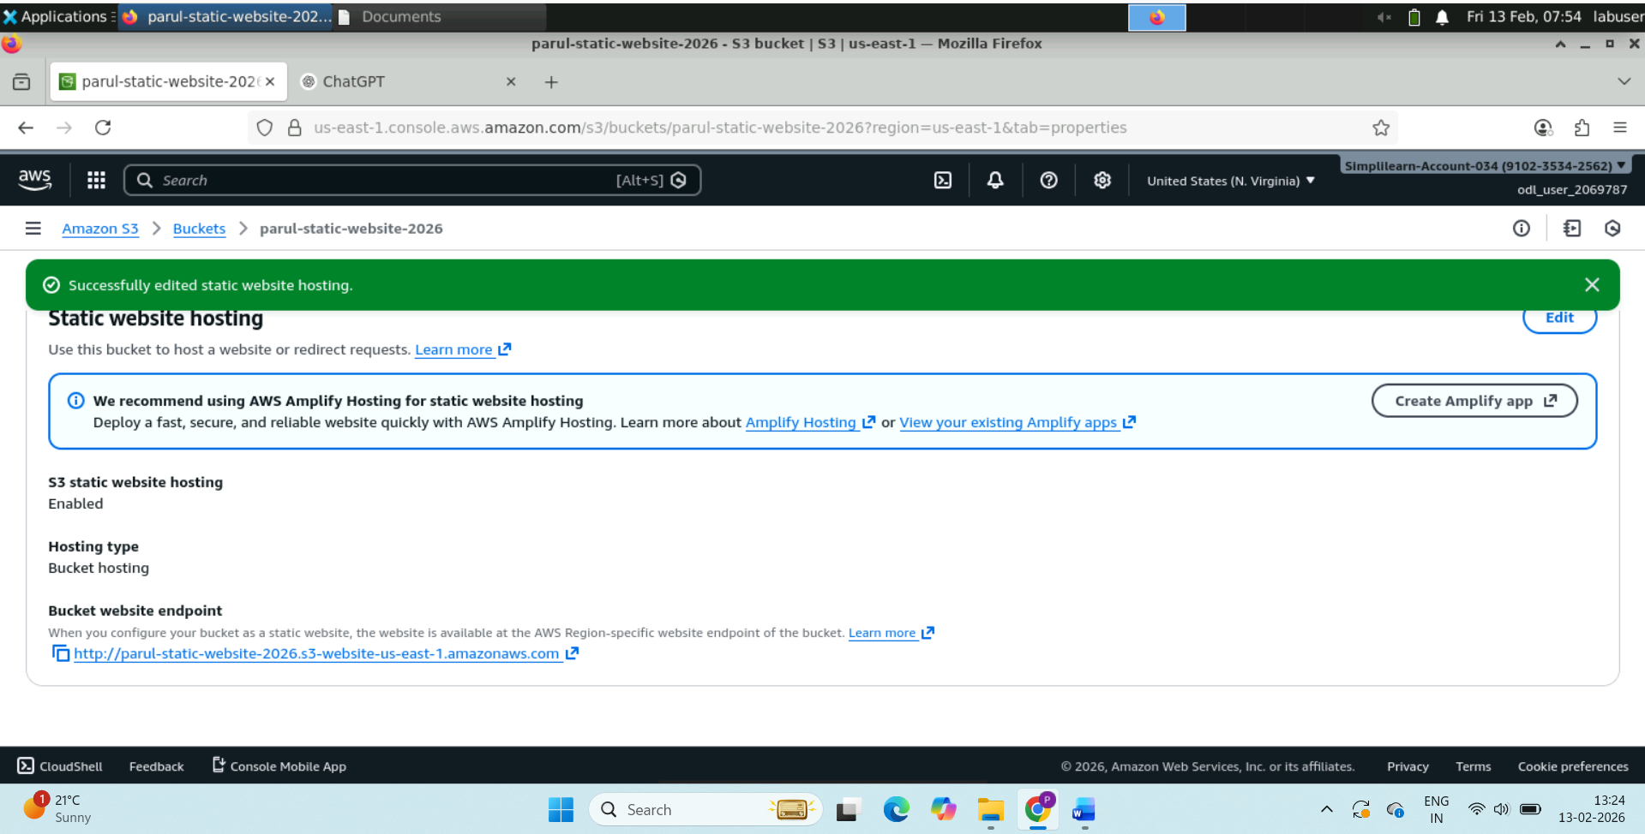

Website is live

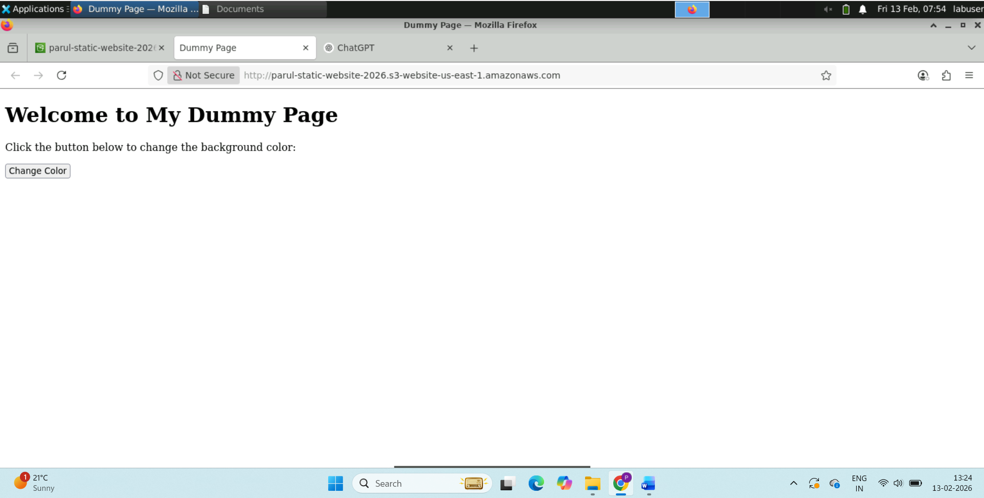

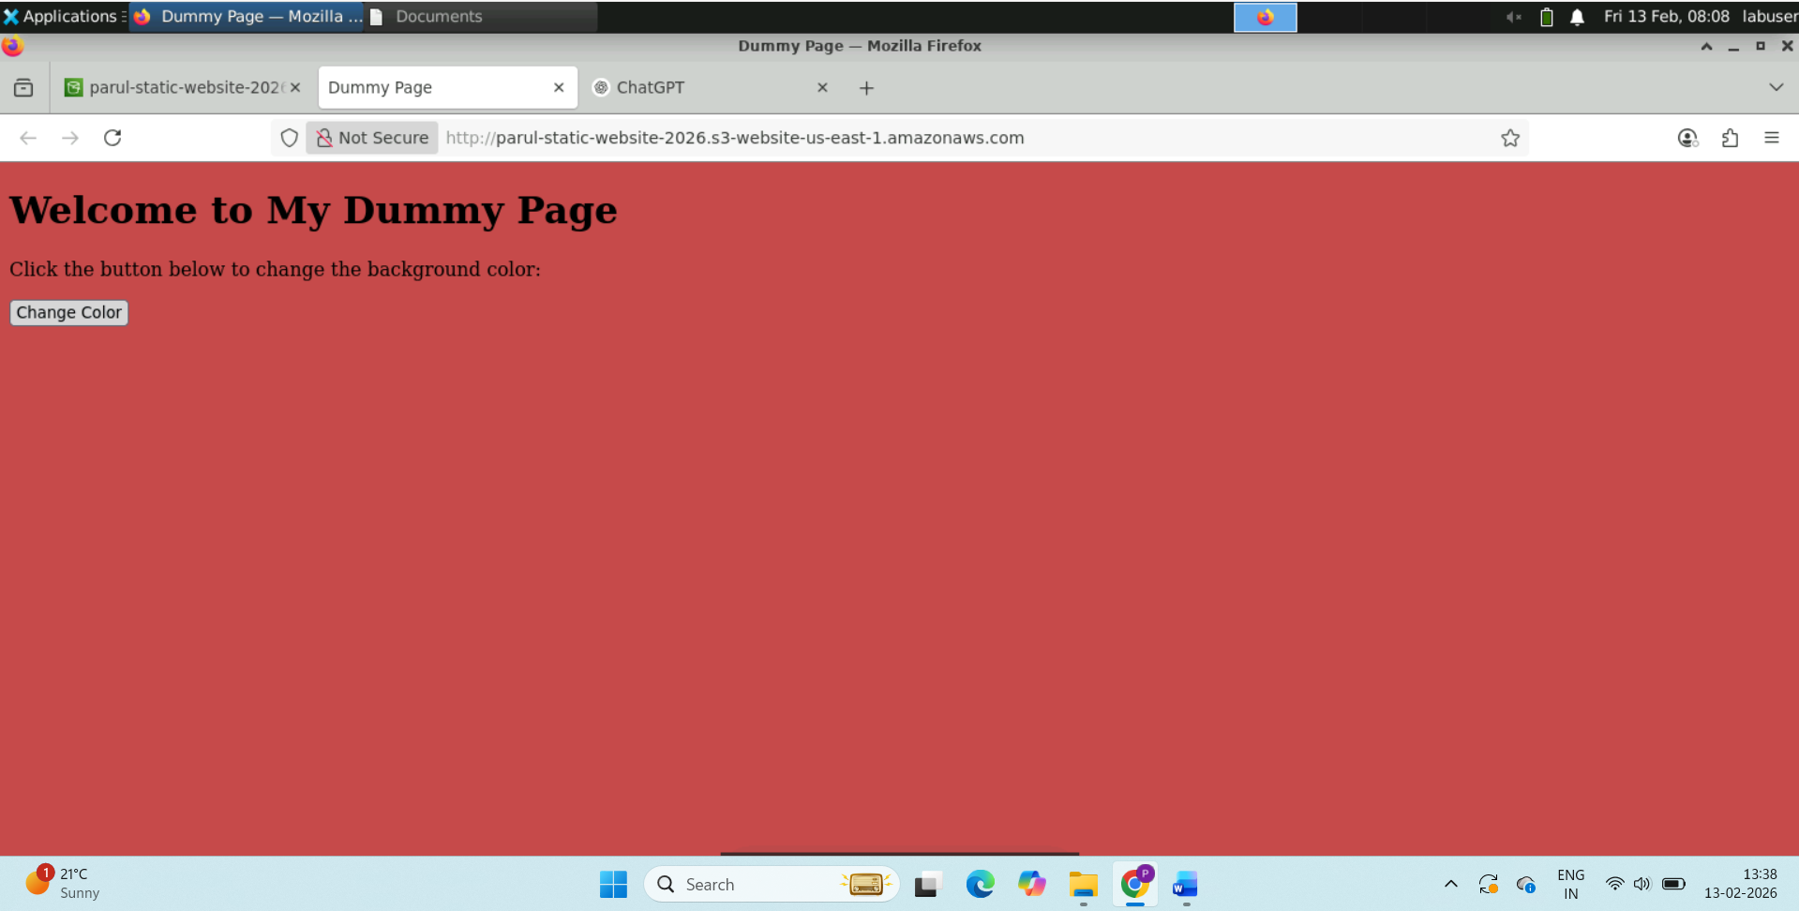

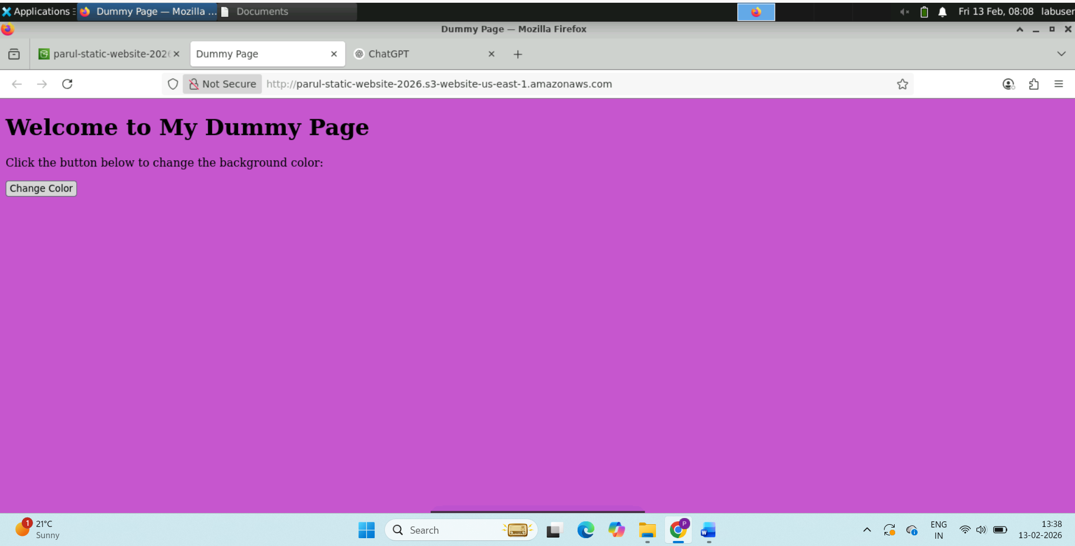

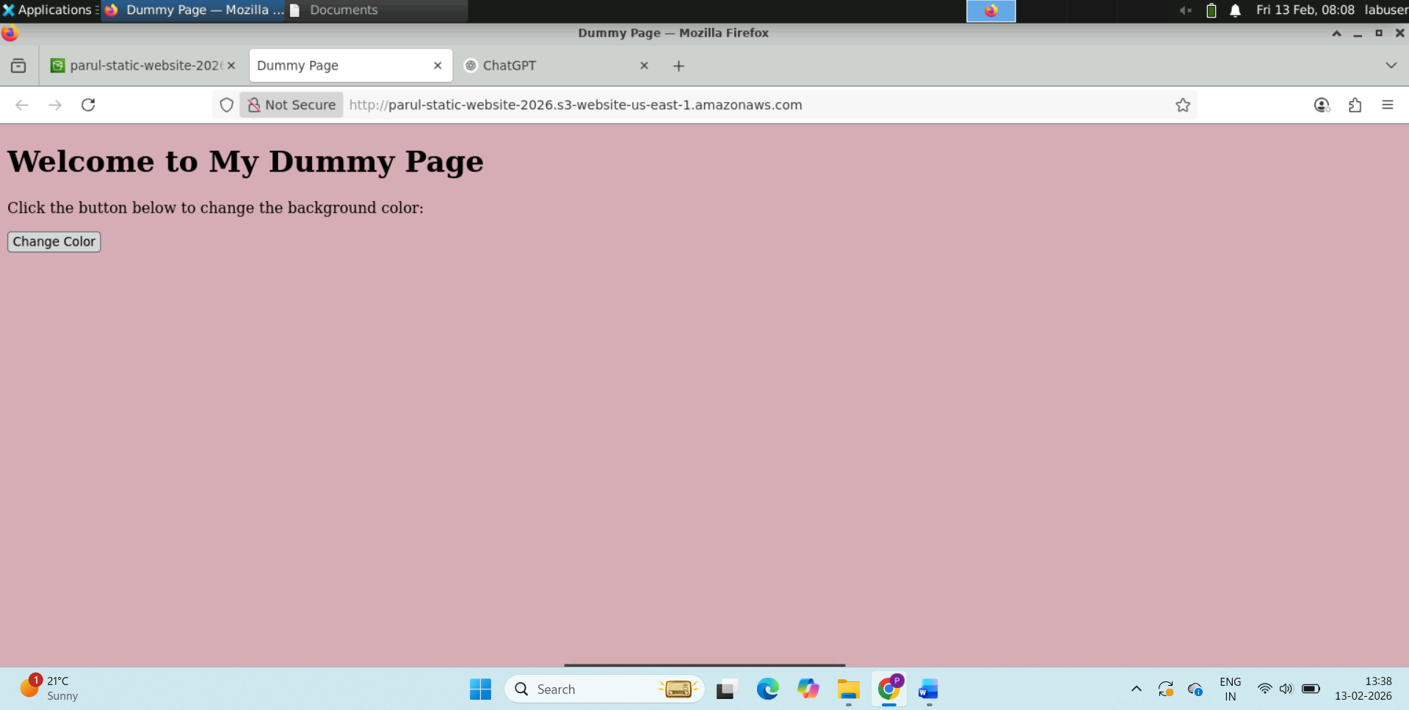

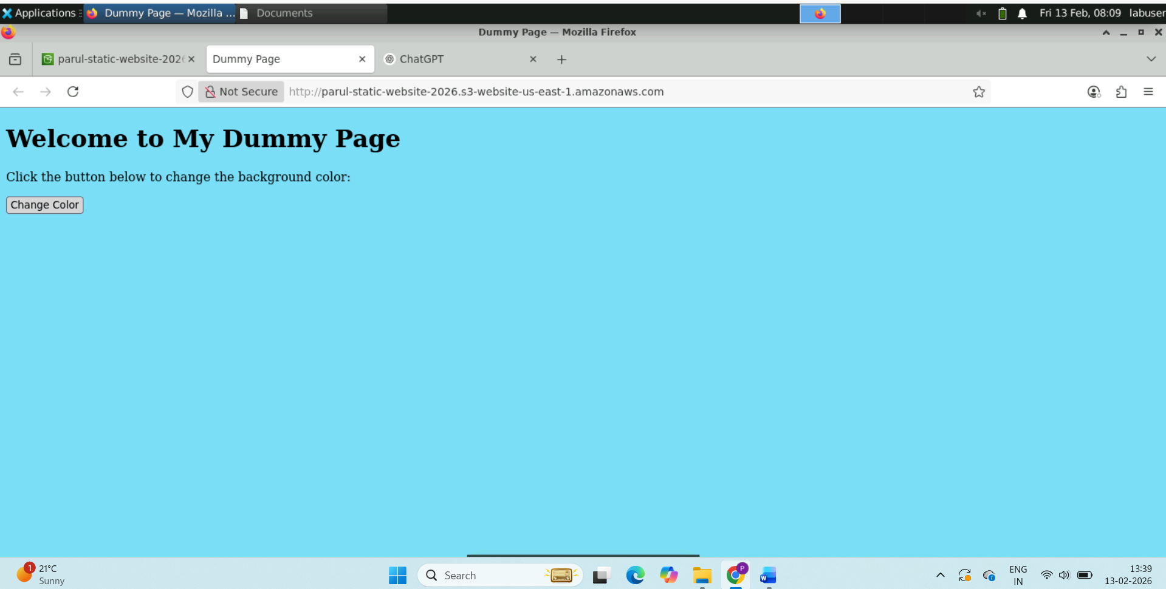

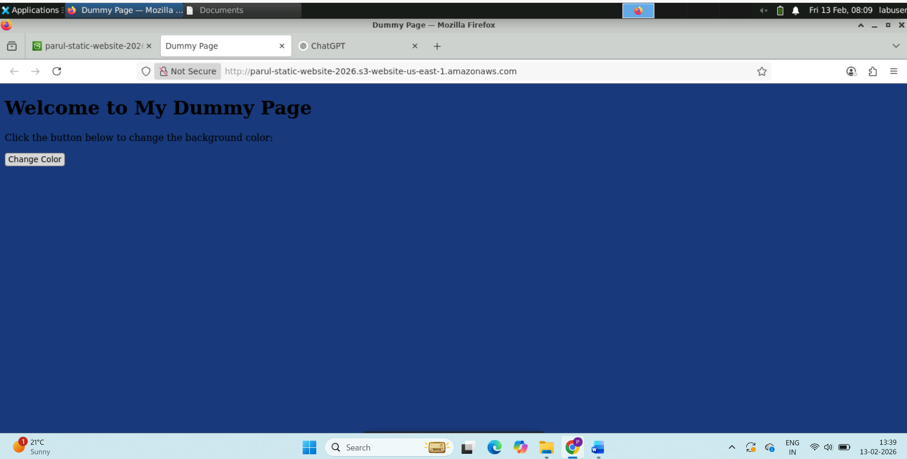

And many more colors.